**Unified pre-payment system**

**User manual for POS:**

1. Open your computer browser ”**Internet Explorer**” and put into the browser url=**192.168.204.18/prepay** **or** Click “**Smart Pay System**” from your computer **task bar.**

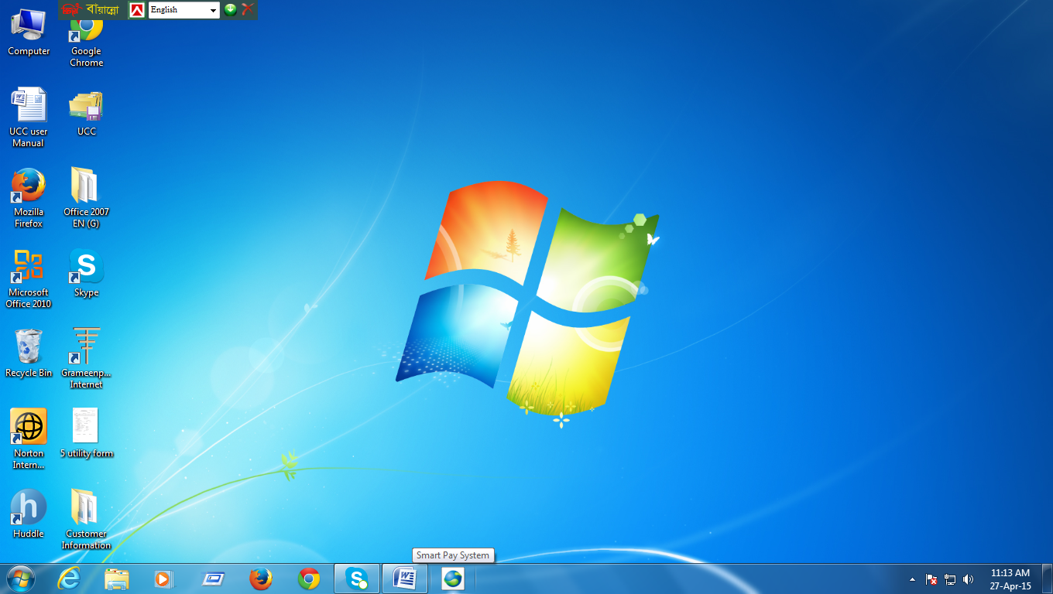

1. Login : Put your **User Name** , **Password** then click **Login**

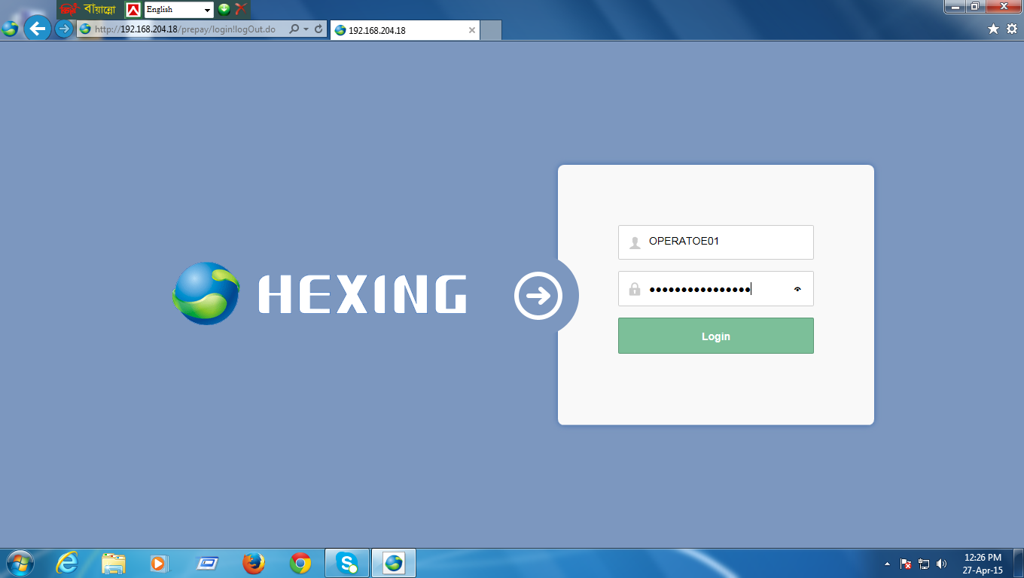

1. For **Vending**

Click **Prepaid > Vending Management >Daily Vending.**

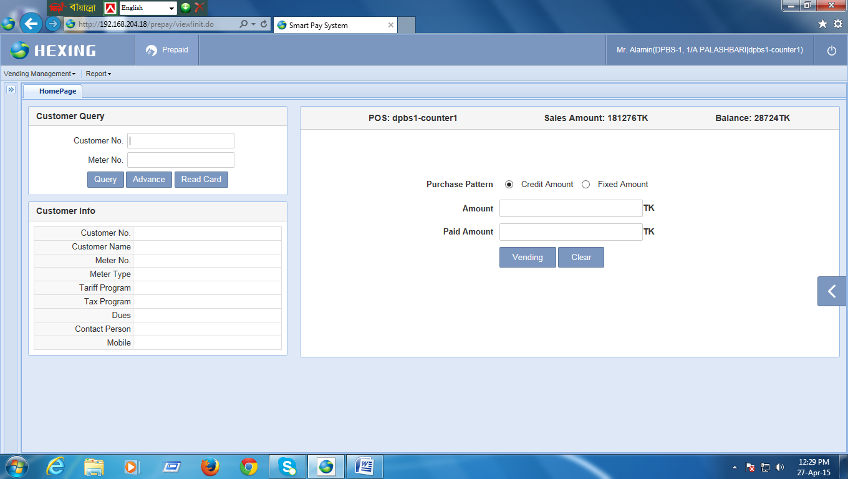

Put into the **Customer** No or **Meter No**. then **Query.**

**Put Recharge Amount then click Vending.**

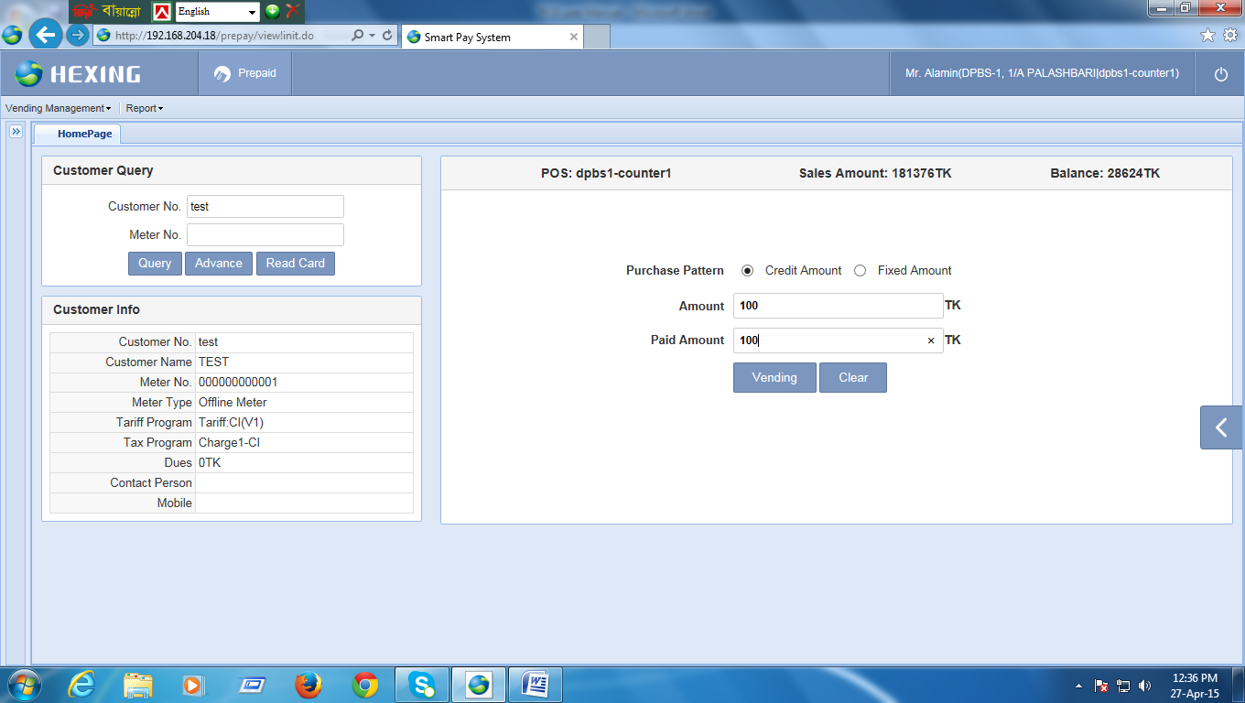

Click **Confirm**

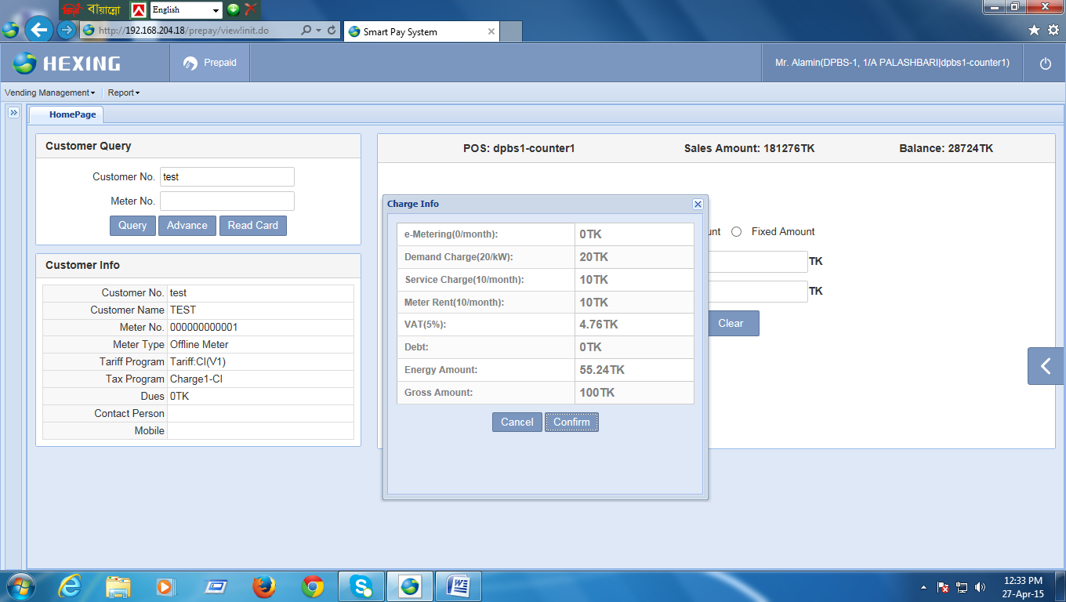

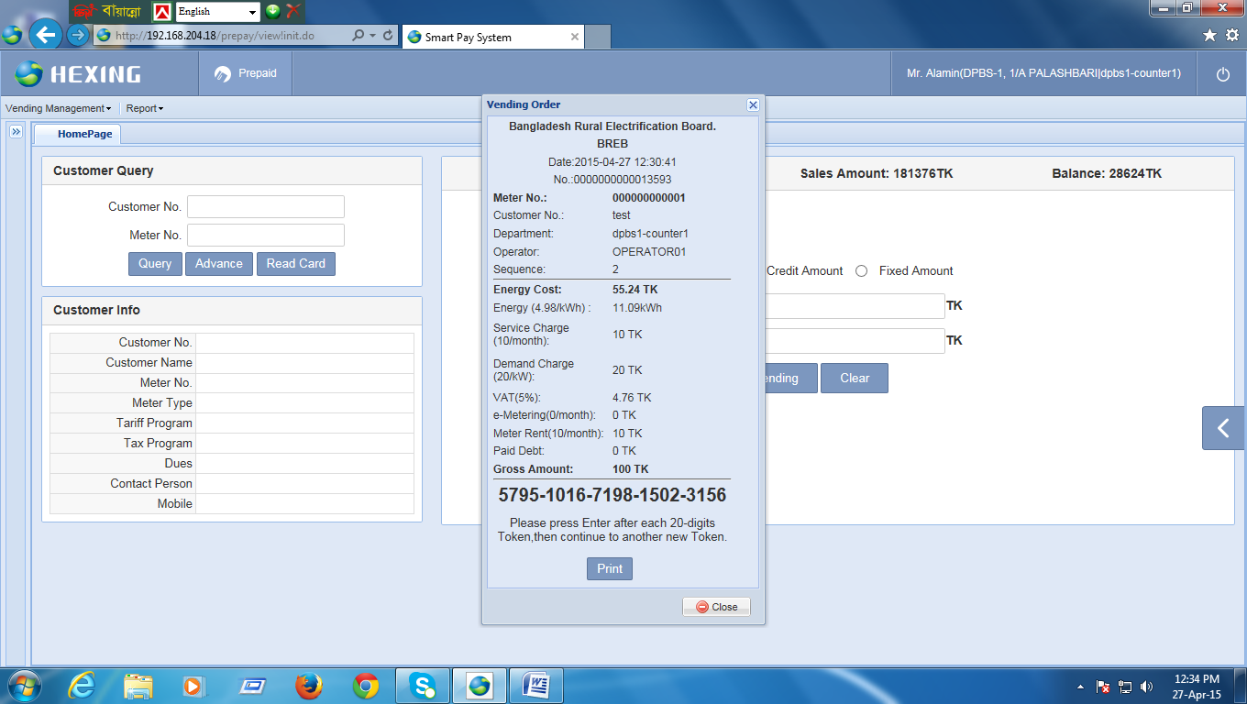

Print **Token**.

and give to the Customer.

1. **Data Reissue.**

**[Note: If the customer lost his token, so you can print again that token from here.]**

Click **Prepaid> Vending Management> Data Reissue.**

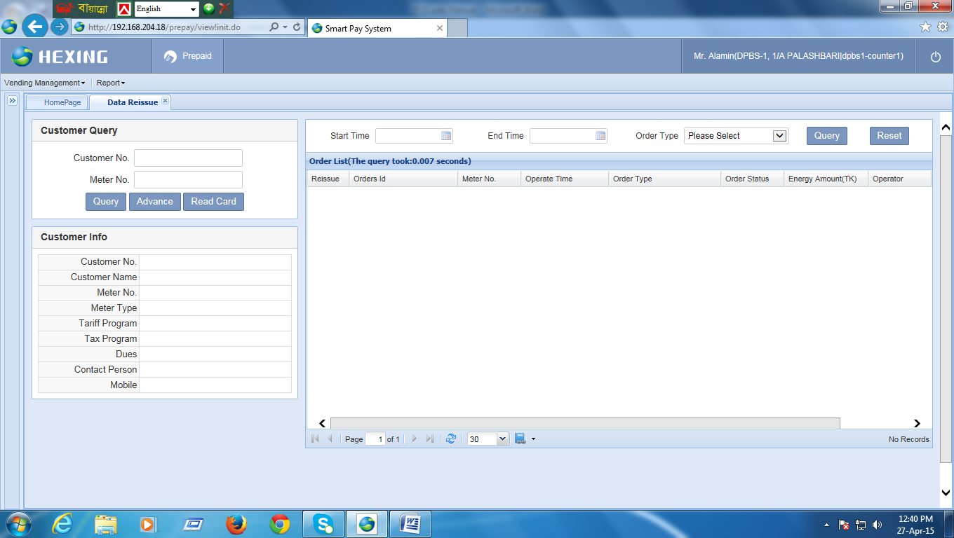

Put into the customer No or Meter No: then Query.

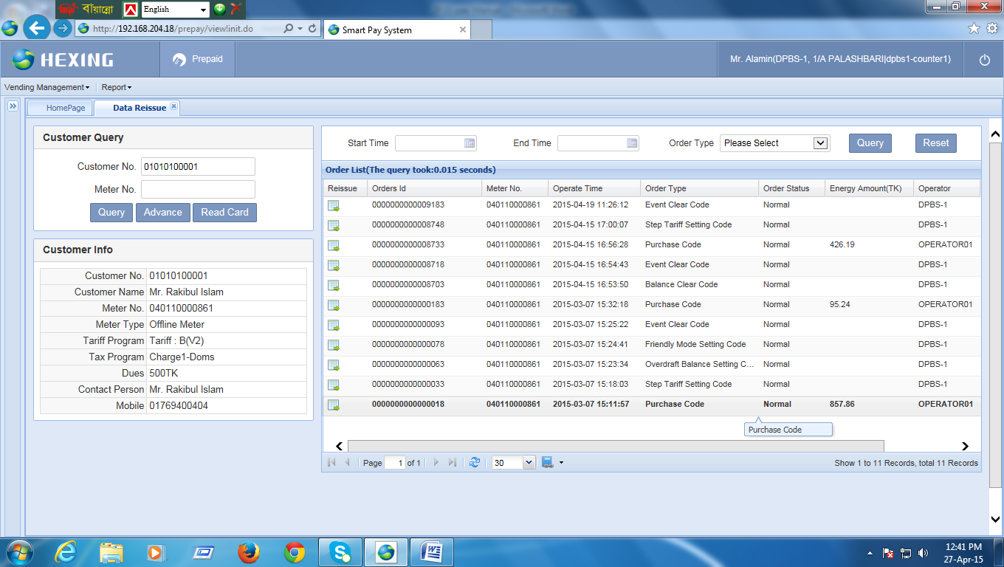

1. For see the daily sales Report.

Click **Prepaid>Report>POS report> Vending Breakdwon.**

**Select date then Query.**

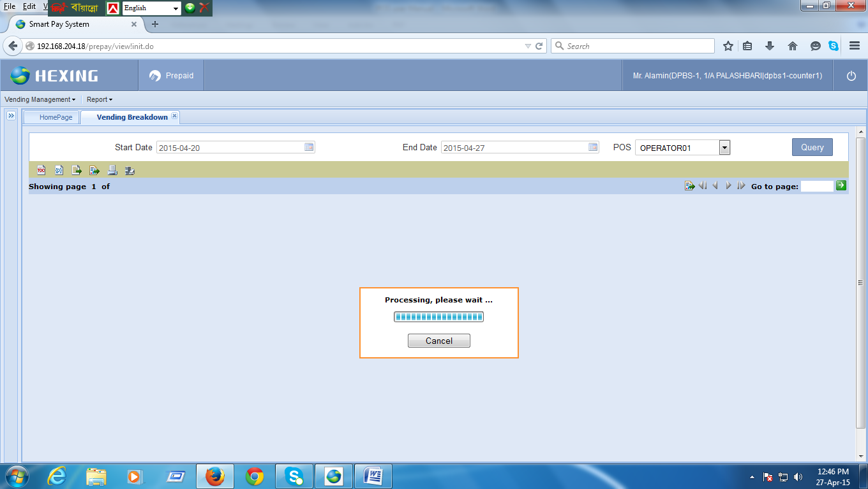

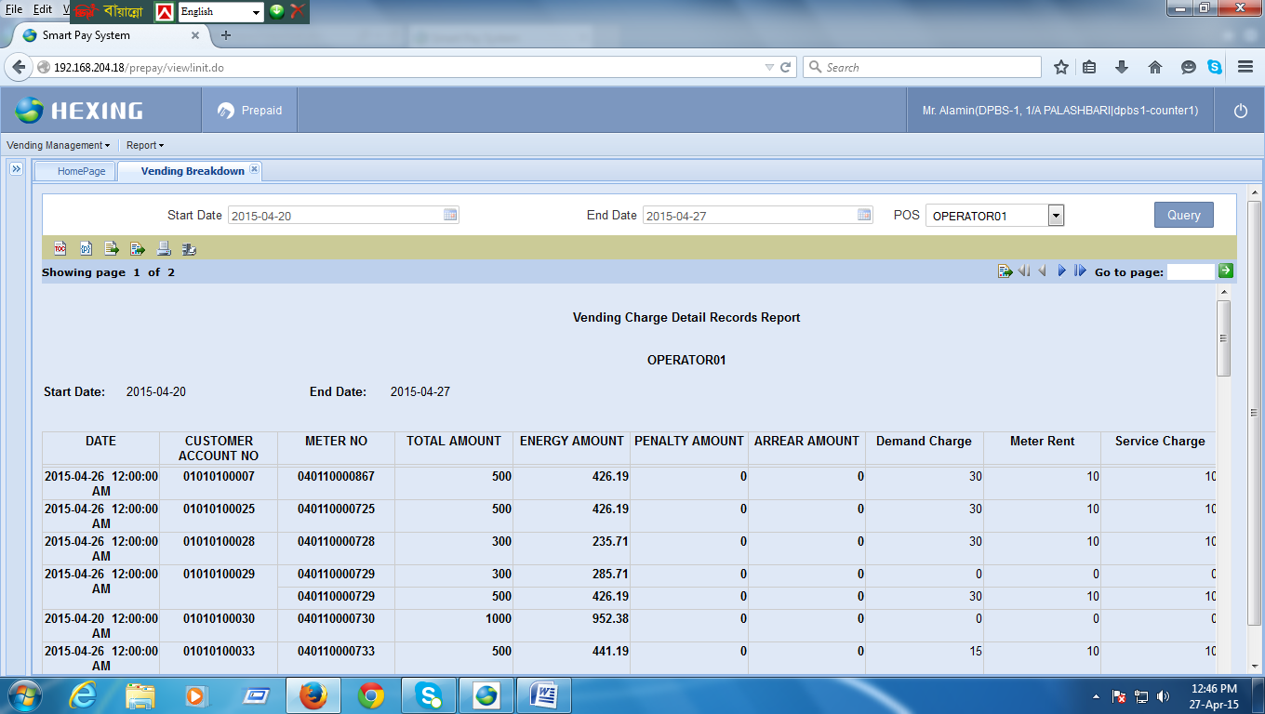

Then **Export** or **Print** this file.